

**How to Guide: Deploy Storefront**

**Business Central**

**Dynamics 365**



**Section X: Description**

**TABLE OF CONTENTS**

1 Introduction 4

2 Implementation Guide 4

2.1 Storefront Business Central Extension App 4

2.2 Deploy Storefront App 4

2.3 Objects 4

2.4 Configure Pages marked as Web Service 5

3 BC Setups 6

3.1 Default Setup – Import RapidStart 6

3.2 Profile / Role 6

3.3 Item Categories 6

3.4 Stock Location 6

3.5 Payment Methods 6

3.6 No. Series 6

3.7 Standard Text 6

3.8 Guest Customer & Identity 6

4 Product Search 6

5 Storefront to Business Central Connector 6

5.1 WSAK - deprecated 6

5.2 Authentication 6

5.3 Network – On Prem Business Central 7

6 SOAP Web Services Client 7

6.1 Update WSDL URLs 7

6.2 Set Credentials 8

7 Payment Service Provider Integration 9

7.1 Refer to ConnectorPSP folder in solution 9

7.2 PayGate 9

7.3 Netcash 9

8 Storefront Web App 9

8.1 Azure Storage Account 9

9 Email Notifications 9

10 Storefront Setup 15

11 User Take-on 16

12 Conclusion 16

# Introduction

Welcome to Storefront, powered by Microsoft Dynamics 365 Business Central!

Storefront is a rapid start ecommerce business management platform. Set up your Products, Prices & Content in no time. Start selling online fast.

The following document outlines how to set up and use Storefront & Storefront Admin.

# Implementation Guide

## Storefront Business Central Extension App

## Deploy Storefront App

## Objects

|  |  |  |  |
| --- | --- | --- | --- |
| **Object** | **ID** | **Name** | **Web Service** |
| Page | 73500 | SalesLineKI | Yes |
| Page | 73501 | SalesHeaderKI | Yes |
| Page | 73502 | CustomerKI | Yes |
| Page | 73503 | ItemKI | Yes |
| Page | 73504 | SalesPriceKI | Yes |
| Page | 73505 | ItemVariantKI | Yes |
| Page | 73506 | AssemblyBOMKI | Yes |
| Page | 73507 | ShipToAddressKI | Yes |
| Page | 73508 | ItemCategoryKI | Yes |
| Page | 73509 | ShippingAgentKI | Yes |
| Page | 73510 | ShippingAgentServicesKI | Yes |
| Page | 73511 | ItemAttributeKI | Yes |
| Page | 73512 | PaymentMethodKI | Yes |
| Page | 73513 | PostCodeKI | Yes |
| Page | 73514 | CurrencyKI | Yes |
| Page | 73515 | IdentityKI | Yes |
| Page | 73516 | AnalyticsKI | Yes |
| Page | 73517 | Storefront Role Center |  |
| Page | 73518 | LocationKI | Yes |
| Page | 73519 | PaymentsKI | Yes |
| Page | 73520 | ItemAttributeValueKI | Yes |
| Page | 73521 | DiscountOfferKI |  |
| Page | 73522 | BasketOfferKI |  |
| Page | 73523 | BasketOfferLineKI | Yes |
| Page | 73524 | Basket Offer List |  |
| Page | 73525 | VoucherKI |  |
| Page | 73526 | SalesInvHeaderKI | Yes |
| Page | 73527 | SalesInvLineKI | Yes |
| Page | 73528 | EmailLogKI |  |
| Page | 73529 | BasketOfferLineKI2 |  |
| Page | 73530 | Price List KI | Yes |
| Table | 73502 | AnalyticsKI |  |
| Table | 73500 | IdentityKI |  |
| Table | 73501 | DiscountOfferKI |  |
| Table | 73503 | PaymentsKI |  |
| Table | 73504 | BasketOfferKI |  |
| Table | 73505 | BasketOfferLineKI |  |
| Table | 73506 | VoucherKI |  |
| Table | 73522 | EmailLogKI |  |
| Codeunit | 73500 | EventHandlerKI |  |
| Codeunit | 73501 | EcommerceMgtKI |  |
| Query | 73514 | Customer Spend SF |  |

## 

## Configure Pages marked as Web Service

SOAP Web Services

|  |  |  |  |
| --- | --- | --- | --- |
| Object Type | Object ID | Object Name | Service Name |
| Page | 73500 | Sales Lines | SalesLineKI |
| Page | 73501 | Sales Documents | SalesHeaderKI |
| Page | 73502 | Customers | CustomerKI |
| Page | 73503 | Items | ItemKI |
| Page | 73504 | Special Prices | SalesPriceKI |
| Page | 73505 | Item Variants | ItemVariantKI |
| Page | 73506 | Assembly BOM | AssemblyBOMKI |
| Page | 73507 | Ship-To Addresses | ShipToAddressKI |
| Page | 73508 | Item Categories | ItemCategoryKI |
| Page | 73509 | Shipping Agents | ShippingAgentKI |
| Page | 73510 | Shipping Agent Services | ShippingAgentServicesKI |
| Page | 73511 | Item Attributes | ItemAttributeKI |
| Page | 73512 | Payment Methods | PaymentMethodKI |
| Page | 73513 | Post Codes | PostCodeKI |
| Page | 73514 | Currencies | CurrencyKI |
| Page | 73515 | Users | IdentityKI |
| Page | 73516 | Datastore | AnalyticsKI |
| Page | 73518 | Locations | LocationKI |
| Page | 73519 | Storefront Payments Log | PaymentsKI |
| Page | 73520 | Item Attribute Values | ItemAttributeValueKI |
| Page | 73523 | Basket | BasketOfferLineKI |
| Page | 73526 | Sales Invoice Headers | SalesInvHeaderKI |
| Page | 73527 | Sales Invoice Lines | SalesInvLineKI |
| Page | 73530 | Price List | PriceListKI |

# BC Setups

## Default Setup – Import RapidStart

## Profile / Role

* Storefront Role Center: Page 73517

## Update existing Documents to view online

* SF Setup > Create Document GUIDs

## Item Categories

* Select top level categories (empty Parent Code / has children) > Calculate Department Filters

## Stock Location

* SF Setup: SETUP INVT LOCATION

## Payment Methods

* Account
* ONLINE: for one PSP, default PSP PayGate
  + Secure online payments powered by PayGate
* NETCASH
* PAYGATE

## No. Series

* New Customer No Series: CUST

## Standard Text

* STOREFRONT COMMENT

## Job Queue

* Schedule Codeunit 73501 "EcommerceMgtKI" every 5 minutes
* Handles emails and batch processes, make order requests etc..

## Guest Customer & Identity

* guest@storefront.co.za

# Product Search

* Export Item List Descriptions
* Add to autocomplete array in js script.

# Storefront to Business Central Connector

## WSAK - deprecated

* A Business Central User account is required.
* Enable the Web Service Access Key on an existing User account to make use of it for authentication.
* Username & Web Service Access Key – Deprecated, replaced by S2S OAuth

## Authentication

* Azure Access Control Service
* Azure Active Directory
* S2S OAuth
* Add Permissions and Storefront Permission Set.

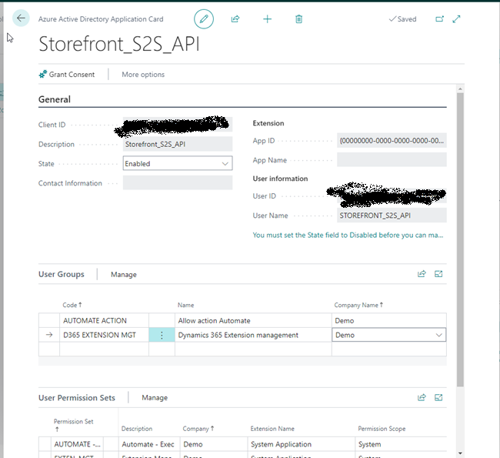

On Prem: A separate Business Central Service required, configured to authenticate as per above required option.

## Network – On Prem Business Central

* Create a secure virtual network between the Storefront web app and the Business Central environment, web services endpoints.

# SOAP Web Services Client

## OAuth

* Requires auth code changes to auto generated classes.
* WDSL updates require local copy to refresh from. 6.2 update function does work with OAuth.

## Update WSDL URLs

* For each web reference, right-click > properties > Web Reference URL
* For each web reference, right-click > Update Web Reference to update the Web Reference definition – manual import required for OAuth
* Point the relevant Business Central SOAP web services URL.
* Build and Deploy to Storefront, ConnectorERP.

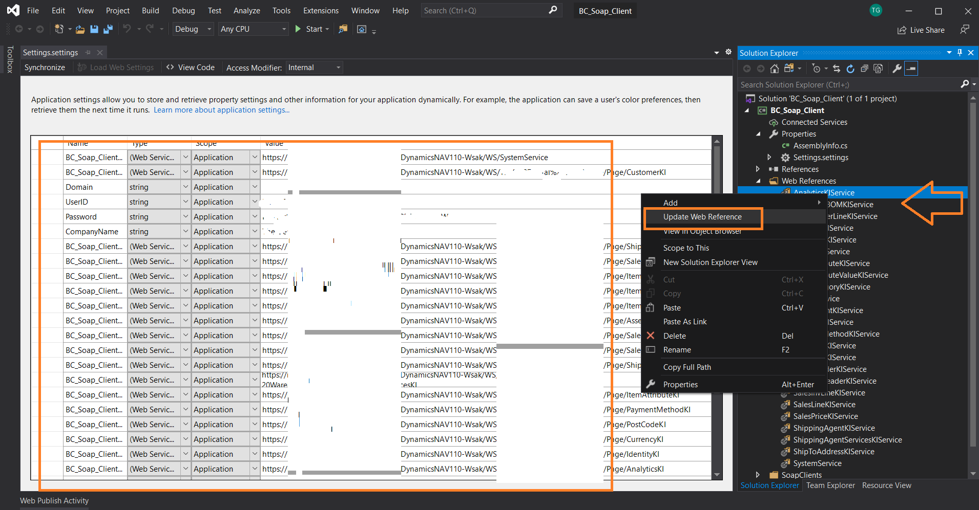

* Verify Settings.settings are the same

## Set Credentials

* Settings.Designer.cs
* App.config

# Payment Service Provider Integration

## Refer to ConnectorPSP folder in solution

## PayGate

PayGate Payment Service Provider Settings in PayWeb3.cs

* PayGate ID
* PayGate Secret

## Netcash

Netcash Payment Service Provider Settings in NetcashPayNow.cs

* PAY_NOW_SERVICE_KEY
* SOFTWARE_VENDOR_KEY

# Storefront Web App

## Azure Storage Account

Set the storage namespace in the ContentController

* containerPrefix
* Format: "<SiteName>-"
* Example: "<CustomerABC>-"

As well as the following, if applicable:

* storageRoot
* connectionString

# Email Notifications

* Configure an email account in Business Central
* Storefront makes use of Business Central’s built-in SMTP email capabilities
* Install SMTP connector Apps:

* Select SMTP

And it will prompt you to add settings:

Afterwards, search for Email Accounts to add / change config:

Assign Storefront email scenario

# Storefront Setup

|  |  |  |  |
| --- | --- | --- | --- |
| P Key | Metric | Text Value | Code Value |
| ATTRIBUTES | Filter Attribute Ids | 8|9|11|12|13 |  |
| DOMAIN | Storefront Online Shop | https://braintree-storefront-demo.azurewebsites.net/ | HTTPS://BRAINTREE-STOREFRONT-DEMO.AZUREWEBSITES.NET/ |
| SETUP ACC PMT METHOD | SETUP ACC PMT METHOD | ACCOUNT |  |
| SETUP ACC REG | Internal Accounts Email - New Accounts | appdev@braintree.co.za |  |
| SETUP ACTIVE CART DAYS |  | 15 |  |
| SETUP CURRENCIES | SETUP CURRENCIES | EUR|GBP|USD |  |
| SETUP EMAIL FROM | Email Notifications | appdev@braintree.co.za |  |
| SETUP FAV LAST RUN |  | 22/03/2023 |  |
|  |  |  |  |
| SETUP FORM | Documents and forms | https://forms.office.com/Pages/ResponsePage.aspx?id=fan7yKFWs0C1L80TrmL39U37nTMToDRGtg1F2pDu9eZUMkNET0FTQTk2MkxCUVBONTlPMUNXMDU5Vy4u |  |
| SETUP FORM 2 | Documents and forms | https://drive.google.com/embeddedfolderview?id=1BFZYMYBcUxoRIfwnuMkUogVjGtqRMgsX#list | WIDTH:100%; HEIGHT:275PX; BORDER:0; |
| SETUP FORM 3 | Documents and forms | https://drive.google.com/embeddedfolderview?id=1BFZYMYBcUxoRIfwnuMkUogVjGtqRMgsX#grid | WIDTH:100%; HEIGHT:275PX; BORDER:0; |
| SETUP INVT LOCATION | Shop Inventory Location Filter |  |  |
| SETUP INVT POST GROUP | SETUP INVT POST GROUP |  |  |
| SETUP LCY | Amount in Curerncy Symbols | R |  |
| SETUP LCY CURRENCY | SETUP LCY CURRENCY | South African Rand (ZAR) | ZAR |
| SETUP MARKETING EMAIL | Submit Feedback Forward to Email | appdev@braintree.co.za |  |
| SETUP ONLINE PMT METHOD | SETUP ONLINE PMT METHOD | ONLINE |  |
| SETUP PAYMENT METHODS | SETUP PAYMENT METHODS | ACCOUNT|ONLINE |  |
| SETUP POST PMT JNL | Post Cash Receipt Journals | Yes |  |
| SETUP PRICE LIST |  | YES |  |
| SETUP PROMO ATTRIBUTE | Promotion Attribute Id | 13 |  |
| SETUP PROMO ATTRIBUTE VALUE | Promotion Attribute Value Id | 90 |  |
| SETUP PROMO ATTRIBUTE2 | Promotion Attribute Id | 13 |  |
| SETUP PROMO ATTRIBUTE2 VALUE | Promotion Attribute Value Id | 91 |  |
| SETUP PROMO CATS | Promoted Categories Filter | AUDIO,MISC,PRO SERVICES,FURNITURE,SERVICES,HOME |  |
| SETUP REFER VOUCHER | Refer a friend Voucher Code | VOUCHER-REFER |  |
| SETUP SHIP AGENT SERVICES | Shipping Services |  |  |
| SETUP SHIP AGENTS | Shipping Agents | OWN LOG. |  |
| SETUP SIGNUP VOUCHER | Sign Up Voucher Code | VOUCHER-SIGNUP |  |
| SETUP SURVEY | Sign Up WSurvey | https://forms.office.com/Pages/ResponsePage.aspx?id=fan7yKFWs0C1L80TrmL39U37nTMToDRGtg1F2pDu9eZUMkNET0FTQTk2MkxCUVBONTlPMUNXMDU5Vy4u |  |

# User Take-on

* Create new Storefront Users
* Manually
* Action from the Customer Card
* Make use of Co. Name __TAKEON__ for plain text passwords
  + These should be changed upon first login using the Forgot Password function

# Conclusion

For additional assistance, please contact us at [info@braintree.co.za](mailto:info@braintree.co.za).